Title here. Use the prepared "Style" to fit the style
Author11*, Author22,3
¹Center for Relativistic Laser Science, IBS, Gwangju, Korea; ²Advanced Photonics Research Institute, GIST, Gwangju, Korea; 3Dept. of Physics and Photon Science, GIST, Gwangju, Korea
*corresponding author: aaa@bbb.ac.kr
Put your abstract here. Use the prepared "Style". Include a figure and fill the whole 1 page, if possible. This template is based on the template made by the ICUIL 2018 LOC (Lindau, Germany). Sample text follows.
We have demonstrated the amplification and subsequent recompression of optical chirped pulses [1]. We report here a demonstration of laser intensity exceeding ${10}^{29} W/cm^{2}$. We obtained nearly diffraction-limited focusing with a spot size of $1.1 μm$ (FWHM). From the measurement of 1000 consecutive laser shots, a peak intensity of $\left(1.1±0.2\right)×{10}^{29} W/cm^{2}$ was achieved [2]. Generation of strong gamma rays via nonlinear Compton scattering has been a fascinating topic in ultra-intense laser physics both as a manifestation of strong-field quantum electrodynamic processes and as a potential mechanism for intense gamma ray sources. In this regard, we propose a scheme based on double-layer targets for efficiently realizing nonlinear Compton scattering and thus generating strong gamma rays [1]. In this scheme, an ultra-intense laser pulse propagates through a near-critical-density layer, becoming stronger by relativistic self-focusing and accelerating copious ambient electrons by direct laser acceleration mechanism [2], as shown in Fig. 1. Then the laser pulse is reflected by a solid-density layer and collides with the accelerated electrons, resulting in a strong nonlinear Compton scattering. From 3D simulations with a particle-in-cell code including strong-field quantum electrodynamics modules [3], we found that 2.6×1012 gamma-ray photons (energy > 1 MeV) can be generated with a 28-fs laser pulse with a peak intensity of 5.3×1021 W/cm2, achieving a conversion efficiency of 10-2. Furthermore, using high-energy particle simulations with a standard code [4], we present an analysis of the pair creation by such strong gamma rays via Bethe-Heitler process.
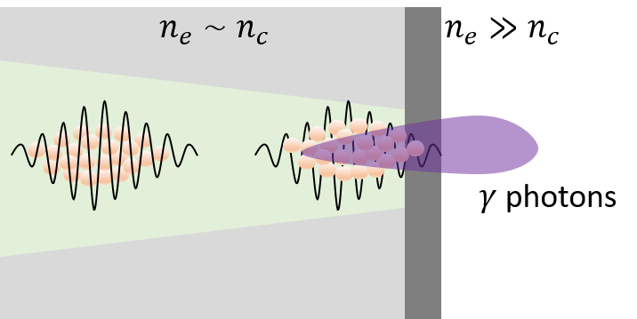
Figure 1: Schematic diagram.

References
[1] D. Strickland and G. Mourou, Opt. Comm. 55, 447 (1985). "Apply PP_Bold in Style to the volume number to make it bold".
[2] A. B. Who et al., Optica 100, 630 (2030).
[3] http://geant4.web.cern.ch/

