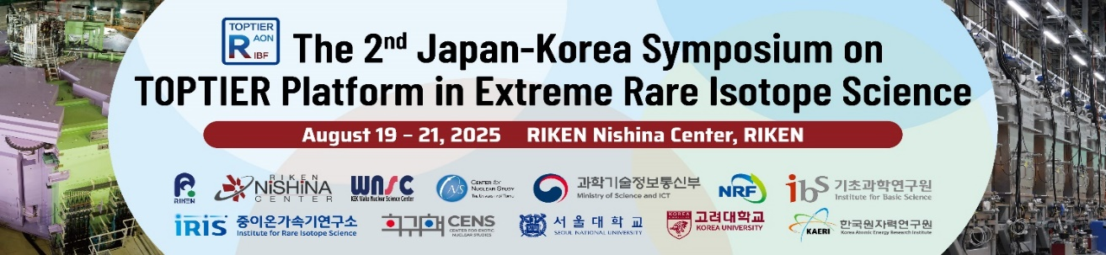

The 2nd Japan-Korea Symposium on TOPTIER Platform
in Extreme Rare Isotope Science
Aug 19 – 21, 2025
RIKEN Nishina Center, RIKEN

Aug 19(Tue)
Place: Conference Room at the Headquarters building

12:00-13:30 Registration & Business lunch with the guests
13:30-14:30 Opening session (15min)
Hiroyoshi Sakurai (TOPTIER Director, RIKEN)
Taeksu Shin (TOPTIER Director, IBS/IRIS)

Greetings (15min)
Akira Henda (Director, Office for Particle and Nuclear Research Promotion, MEXT)
Hyein Kim
(Science & Technology, ICT Counsellor, Embassy of the Republic of Korea)
Seung-Woo Hong (Former Director of IRIS, IBS)

The Overview of RIKEN&IBS (20min)
Osamu Aruga (Division Director, Global Strategy Division, RIKEN)
Shibo Sim (Head of Office of Global Relations and Communications, IBS)

Photo session (10min)

14:30-15:00 Coffee break

Parallel Sessions I
Guest event
14:30-16:00 RIBF Tour

TOPTIER Scientific Program

Aug 19(Tue) Parallel Sessions II

Session 1: RI Production
Conveners: Y. Watanabe/D.S. Ahn

15:00-15:05 Overview Y. Watanabe (KEK)
15:05-15:30 Status of RI Production at RAON T. Shin (IBS)
15:30-15:45 Development of the apparatuses for energy-degraded RI beam experiments
at OEDO N. Imai (CNS)
15:45-16:00 Optics study of 15 and 5 MeV/nucleon beam at OEDO
Y. Yamamoto (CNS)
16:00-16:10 Development of ASAGI for SR-PPAC R. Tsuchiya (Rikkyo Univ/
BigRIPS)
16:10-16:30 Coffee Break
16:30-16:45 Medical isotopes program at IRIS JH Kim(IBS)
16:45-17:00 Recent status of the low-energy RI beam production at CRIB
H. Yamaguchi (CNS)
17:00-17:15 RI production at KISS: MNT reactions and laser ionization
Y. Hirayama (KEK)

18:00-20:00 Dinner (Buffet style) at the Headquarters building 2F

Aug 20 (Wed)
Place: Conference Room at the RIBF building

Session 2: Spectroscopy
Conveners: N. Aoi/B. Hong

09:30-09:40 Summary of Project 2 Activities N. Aoi (CNS)
09:40-10:10 Status of the IDATEN project at RIBF and the upcoming ASGARD
in-beam gamma campaign at RAON H. Watanabe (CENS/IBS)
10:10-10:30 Lifetime measurement of yrast-band states in 94Pb using IDATEN
Y. Jang (CENS/IBS)
10:30-10:50 Coffee Break
10:50-11:20 In-Beam Gamma-Ray Spectroscopy with DALI2(+), HiCARI, and the Path
Toward HYPATIA P. Doornenbal (RIKEN)
11:20-11:40 Status of in-beam gamma spectroscopy for the neutron-rich scandium
isotopes with HiCARI campaign J. Kim (Korea University)
11:40-12:00 C2URIE Y. Rin (CNS)

12:00-13:45 Lunch (Cafeteria)

Session 3a: Theory
Conveners: M. Kimura/Y. Kim

13:45-14:10 A new combination of nuclear structure and reaction theories
K. Yoshida (RCNP/RIKEN)
14:10-14:35 Interdisciplinary approach to multi-body correlations
H. Tajima (Univ. of Tokyo)
14:35-15:00 Role of the Light Mass Nuclear Reactions in the r-process
Nucleosynthesis K. Kim (IRIS/IBS)
15:00-15:30 Coffee break

Session 4: Nuclear Matter
Conveners: T. Uesaka/J. K. Ahn

15:30-15:50 Status of the SUPER Project Y.J. Kim (Korea Univ)
15:50-16:10 Cluster knockout measurements at RIBF Y. Kubota (RIKEN)
16:10-16:30 ONOKORO@RCNP C. S. Lee (IBS)
16:30-16:50 Heavy ion collision experiment at RIBF to study the properties of high
dense neutron rich matter T. Isobe (RIKEN)
16:50-17:00 Coffee break
17:00-17:20 Experimental studies with the LAMPS neutron detector array at SAMURAI
Y. Kondo (RIKEN)
17:20-17:40 Preparation Status of LAMPS-NDA Y.J. Kim (IRIS/IBS)
17:40-18:00 Data Acquisition System for LAMPS-NDA
H. S. Lee (IRIS/IBS)

18:00-20:00 Dinner

Aug 21 (Thu)

Session 5: Nuclear Astrophysics
Conveners: S. Nishimura/T. Ahn

09:30-09:40 Overview of Project-4 S.Nishimura (RIKEN)
09:40-10:10 From Masses to β-Decay: Experimental Constraints on the r-Process
V.H. Phong (RIKEN)
10:10-10:35 Stellar nucleosynthesis studies with surrogate reactions
Sunghan Bae (IRIS/IBS)
10:30-10:50 OPM(optical model potential) studies at RAON
D. Kim (CENS/IBS)
10:50-11:10 Coffee break
11:10-11:40 CENS ap-explore project using active target TPCs
S.M. Cha (CENS/IBS)
11:40-12:00 Study on the rp-process via mass measurements with MRTOF-MS
S. Kimura (KEK)

12:00-13:00 Lunch
Session 3b: Theory
Conveners: M. Kimura/Y. Kim

13:00-13:15 Current Status of TOPTIER Theory (KSHELL)
Y.M. Kim (CENS/IBS)

Session 2b: Spectroscopy
Conveners: N. Aoi/B. Hong

13:15-13:35 8pi Array Project at RCNP E. Ideguchi (RCNP)
13:35-13:45 Coffee break

Session 6: Neutron Science
Conveners: H. Otsu/D. H. Kim

13:45-14:05 Status of Project 5 : Neutron Science H. Otsu (RIKEN)
14:05-14:25 Evaluation and Status of Nuclear Data Induced by Neutron for Key
Nuclides in Small MSRs H.I. Kim (KAERI)
14:25-14:45 Neutron Beamline NDPS at IRIS for Nulcear Science
C.S. Lee (IRIS/IBS)
14:45-15:00 Surrogate measurement for the neutron-induced reactions with OEDO
facility N. Imai (CNS)
15:00-15:15 Experimental Approaches for Nuclear Data Production in the TOPTIER
Project D.H. Moon (KAERI)
15:15-15:30 Coffee break

Session 7: Mass, Moment and Ion Trapping
Conveners: H. Ueno/S. Choi

15:30-16:00 Recent progress and technological upgrades for the ZD MRTOF-MS experiment at RIBF M. Rosenbusch (RIKEN)
16:00-16:15 SLOWRI pre-proposal T. Hashimoto (IRIS/IBS)
16:15-16:30 MR TOF and mass measurement J.Y. Moon (IRIS/IBS)
16:30-16:45 Laser spectroscopy at KISS Y. Hirayama (KEK)
16:45-17:00 Coffee break

17:00-18:00 Closing

18:00-20:00 Dinner

